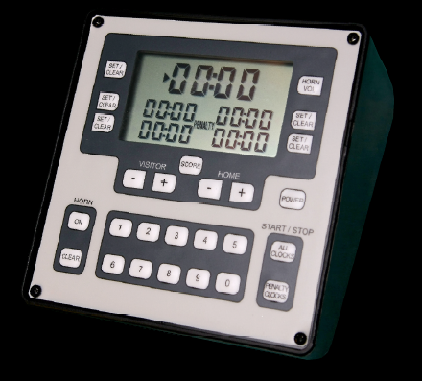

DANGER! Internal HORN is very loud, NEVER direct it at anyone’s ear as it may cause injury. Please note LAX Clock must be protected in the rain!

POWER UP / DOWN
Depressing the POWER key turns on the LAX Clock. When first turned on a short diagnostic will execute to allow verification of the LCD & Horn. All LCD segments & Icons will turn on for 3 seconds. Upon completion all LCDs timers will display 00:00. To turn the LAX Clock off press and hold the POWER key for 2 seconds.

HORN VOL KEY
The GAME HORN is controlled between LOUD / LOW volume by pressing this key. On power up the volume defaults to LOUD and is indicated by the display of the HORN ICON. Pressing this key will toggle the volume between LOUD / LOW and back.

KEEPING SCORE
The lower two PENALTY timers allow the timer keeper to also track team scores. Depressing the SCORE key activates the scoreboard mode. Once in scoreboard mode VISITOR & HOME score is changed by depressing the + key (to increment) and – key (to decrement) the scores. To exit the SCORE board mode and resume time keeping press the SCORE key again.

ENTERING TIMES
Depress the desired Timer’s SET / CLEAR key to select the Timer that will receive the inputted time, note that the associated POINTER ICON will be on. Enter the desired countdown time via the numeric keypad & depress the Timer’s SET / CLEAR key to exit the time entry mode.
EXAMPLE - To enter 30 sec. PENALTY time, 10 Min. GAME TIME and start clocks running perform the following steps:
1 - Depress left PENALTY timer’s SET / CLEAR key, observe it’s associated POINTER ICON turns on.
2 - On the numeric keypad depress 3 followed by 0.
3 - Depress GAME CLOCK timer’s SET / CLEAR key, observe its associated POINTER ICON turns on & PENALTY POINTER ICON extinguishes.
4 - On the numeric keypad depress 1 followed by 0,0,0.
5 - Depress ALL CLOCKS key to start both timers running.

STARTING / STOPPING TIMERS
STARTING - Depress ALL CLOCKS key or PENALTY CLOCKS key, will start any halted timer with count down time remaining.
STOPPING – (For RUNNING Game Clock Mode used by P.L.A.Y.)
Depressing the START/STOP PENALTY CLOCKS key will stop all PENALTY timers from counting down while the GAME timer will continue counting down. Use this key when you need the LAX Clock to time games that require a Running Game Clock.

RESETTING TIMERS - To reset a timer to 0 stop it from counting down as specified above and depress its associated SET / CLEAR key.

RESETTING / SOUNDING THE ALARM
RESETTING - When a timer reaches 0 it will sound the alarm and turn on its associated POINTER ICON. Resetting an alarm condition for any timer is accomplished by pressing the HORN CLEAR key.
EXAMPLE - Enter 3 sec into a Penalty timer, 9 sec. into the Game timer and 6 sec. into another Penalty timer. Depress the ALL CLOCKS key on the right side of the LAX Clock. Each time a timer reaches 0, clear its alarm by depressing the HORN CLEAR key on the left side of the LAX CLOCK.

SOUNDING ALARM - To turn on the internal HORN depress the HORN ON key. To turn the internal HORN OFF press the HORN CLEAR key. DANGER! Internal HORN is very loud, NEVER direct it at anyone’s ear as it may cause injury.

BATTERY INSTALLATION:
The LAX Clock uses four AA & two 9V batteries to operate. Installation of the batteries is accomplished by performing the following steps, DO NOT USE RECHARGEABLE BATTERIES. :
1 - Remove the back cover.
2 –Install batteries matching polarity shown in battery compartment.
Start your season with a fresh set of batteries,
3 - Reattach the bottom cover.

TECHNICAL SUPPORT
If you have any problems please email me at jpapu@laxclock.com. I will respond back to you before the end of the day.

